**Global Smoking Trends: Exploratory Analysis**

**Figure 1:** Average Percent of Male Smokers Per Country since 1988

**Figure 2:** Average Percent of Female Smokers Per Country since 1988

**Figure 1:** Average Percentage of Male Smokers by Country  
Figure 1 presents a choropleth map visualizing the average percentage of male smokers across countries, using a warm orange-red color scale to represent varying prevalence levels. Each country is shaded based on the average proportion of its male population that smokes, calculated from available yearly data. Darker shades indicate higher smoking prevalence. Countries with missing or unavailable data are displayed in light grey with diagonal hatching, clearly distinguishing them from those with reported statistics. This visualization highlights regional trends, showing particularly high smoking rates among men in Eastern Europe, parts of Asia, and some Pacific nations.

**Figure 2:** Average Percentage of Female Smokers by Country  
Figure 2 mirrors the structure and style of Figure 1 but focuses on the average percentage of female smokers by country. It uses the same color scheme and geographical representation, offering a clear comparison to male smoking patterns. The map reveals a generally lower prevalence of smoking among women globally, with notable pockets of higher rates in Western Europe and some island nations. Like Figure 1, countries lacking sufficient data are marked in light grey with hatch marks. Together, these maps provide a comparative view of gender-based smoking behaviors across the world, emphasizing both regional disparities and global public health challenges.

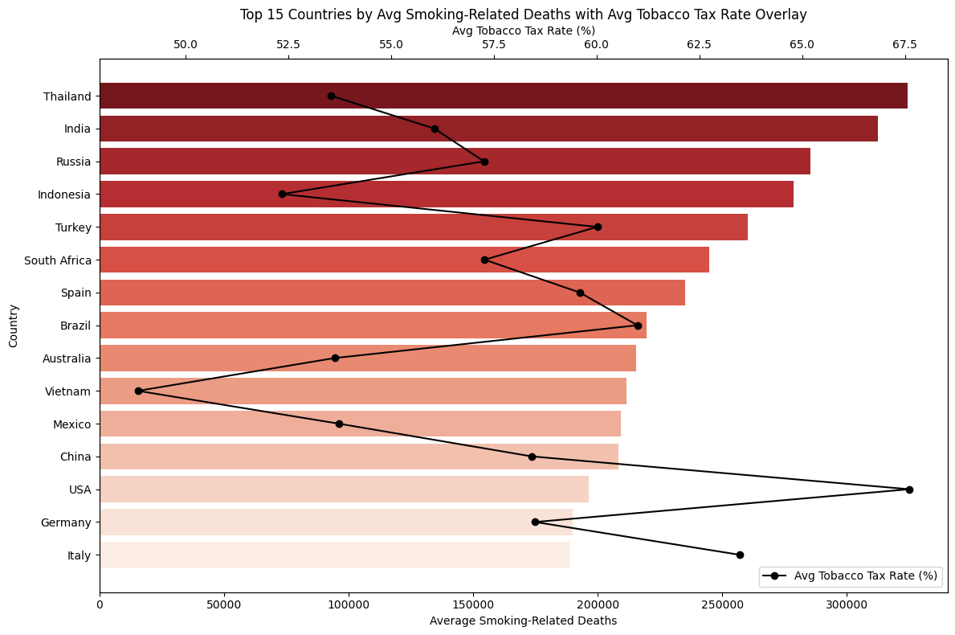

**Figure 3: Top 15 Countries by Average Smoking-Related Deaths with Average Tobacco Tax Rate Overlay**  
Figure 3 illustrates the top 15 countries with the highest **average smoking-related deaths**, calculated over all available years in the dataset. The chart uses horizontal red bars to represent the average number of smoking-attributed deaths per country. Overlaid on a secondary X-axis is a black line with dots, showing each country's **average tobacco tax rate (%)**, enabling visual comparison of fiscal policy alongside health outcomes. This dual-axis visualization helps reveal potential correlations between taxation and smoking-related mortality, suggesting that some countries with higher tax rates may experience lower average death counts, though this trend is not uniform across all nations.

**Figure 4:** Number of Countries by Smoking Ban Policy Each Year  
Figure 4 presents a bar chart showing how many countries implemented each type of smoking ban policy across different years. The bars are grouped by year and segmented by policy type, including categories such as “Comprehensive,” “Partial,” and “None.” This visualization illustrates the global shift in public health regulation, with an observable increase in comprehensive smoking bans in more recent years. It highlights both the temporal expansion of tobacco control policies and the relative distribution of policy adoption across the dataset.

**Significance Statement:** Understanding global smoking patterns is critical for informing public health policy, economic decision-making, and regulatory frameworks aimed at reducing tobacco-related harm. This project presents a comprehensive visual analysis of international smoking data using Python, combining geographic, temporal, and statistical insights to highlight the distribution, prevalence, and consequences of smoking worldwide. By leveraging data visualization techniques—such as choropleth maps, trend lines, word clouds, and policy breakdowns—this analysis uncovers patterns in cigarette consumption, smoking-related mortality, brand dominance, and the effectiveness of tobacco control measures like tax rates and public smoking bans.

The findings illustrate stark disparities in smoking behavior across countries and over time, while also emphasizing the role of national policy in shaping outcomes. Visualizing these dynamics enables more accessible interpretation of complex datasets, supports evidence-based policy recommendations, and empowers stakeholders—governments, NGOs, researchers, and the public—to take targeted action in combating the global tobacco epidemic. This project not only underscores the scale of smoking’s public health impact but also demonstrates the value of data science tools in addressing real-world health challenges.

**Data and Method:** This project utilizes a comprehensive dataset on global smoking behavior and tobacco control collected from a variety of publicly available sources. The dataset includes records from numerous countries over multiple years and contains variables such as smoking prevalence (total, male, and female), cigarette consumption (in billion units), tobacco tax rates, top cigarette brands, smoking-related deaths, and smoking ban policy types. Each row represents a country-year observation, offering a longitudinal perspective on smoking trends and policy implementation globally. To analyze this data, Python was used as the primary analytical tool, with libraries such as **Pandas** for data manipulation, **Matplotlib** and **Seaborn** for visualization, **GeoPandas** for geographic mapping.

**Github:** [**https://github.com/thelukeb/globalsmoking**](https://github.com/thelukeb/globalsmoking)